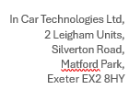
Returns Form
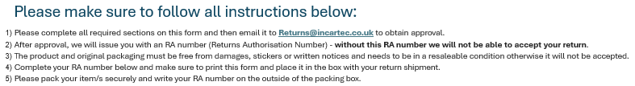
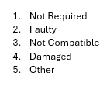

Name/Company |  | RA No. ______________ Date: _________
Email:
QTY | Stock code | Invoice No. | Invoice Date | Return  Code | Reason for return | Car Year, Make & Model
